**1.stereo calibration results**

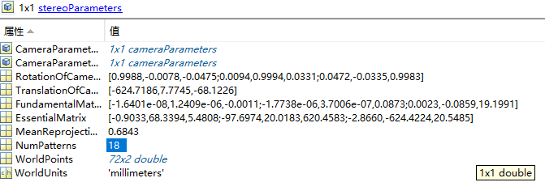

|  |  |  |
| --- | --- | --- |
|  | | |
| **1.1 stereoParams.RotationOfCamera2** | | |
| 0.998842 | -0.0078428 | -0.0474674 |
| 0.00941882 | 0.99940863 | 0.03307073 |
| 0.04717992 | -0.0334795 | 0.99832519 |

|  |  |  |
| --- | --- | --- |
|  | | |
| **1.2 stereoParams.TranslationOfCamera2** | | |
| -624.71864 | 7.77449929 | -68.122574 |

|  |  |  |
| --- | --- | --- |
|  | | |
| **1.3**  **stereoParams.FundamentalMatrix** | | |
| -1.64E-08 | 1.24E-06 | -0.0010808 |
| -1.77E-06 | 3.70E-07 | 0.08727884 |
| 0.0022591 | -0.0859201 | 19.1991097 |

|  |  |  |
| --- | --- | --- |
|  | | |
| **1.4 stereoParams.EssentialMatrix** | | |
| -0.9033048 | 68.3393968 | 5.48076702 |
| -97.697432 | 20.0182698 | 620.458335 |
| -2.8659699 | -624.42243 | 20.5484832 |

|  |
| --- |
|  |
| **1.5 stereoParams.MeanReprojectionError** |
| 0.684314059 |

|  |
| --- |
| table6 |
| **1.6**  **stereoParams.NumPatterns** |
| 18 |

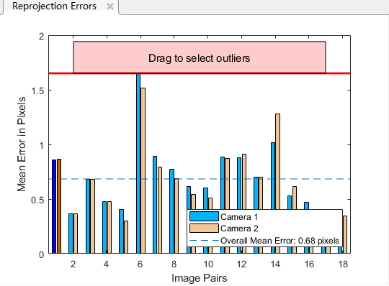

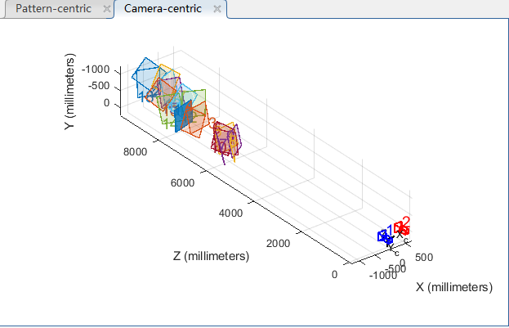

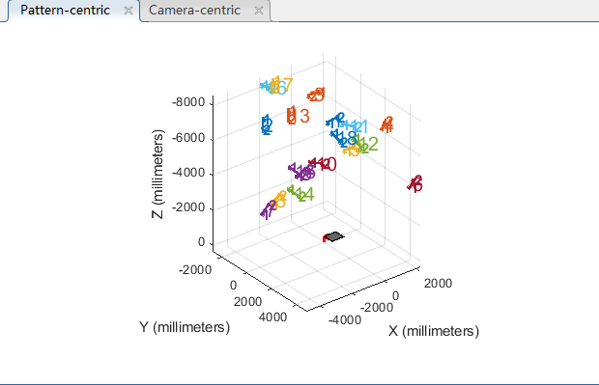

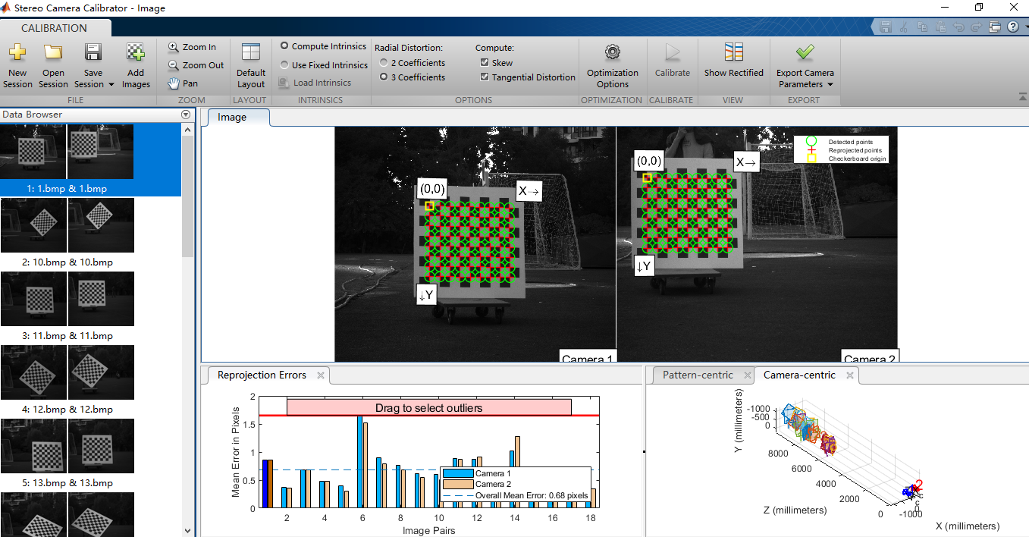

**2.single camera parameters**

**2.1 left camera**

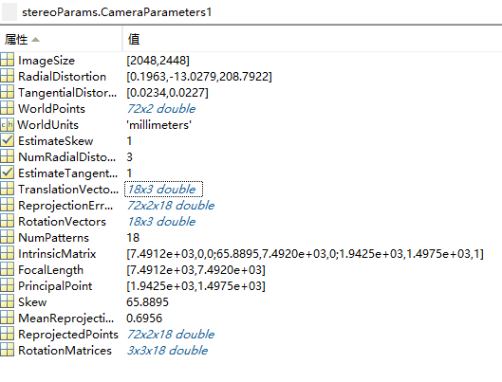

**2.1.1 stereoParams.CameraParameters1.IntrinsicMatrix**

7491.20599927464 0 0

65.8894515063429 7491.97168906742 0

1942.52279709139 1497.45072963980 1

**2.1.2 stereoParams.CameraParameters1.RotationMatrices**

val(:,:,1) =

0.9653 0.0078 0.2609

0.0108 0.9975 -0.0698

-0.2608 0.0702 0.9628

val(:,:,2) =

-0.6328 -0.6665 0.3942

0.7165 -0.6970 -0.0282

0.2935 0.2646 0.9186

val(:,:,3) =

-0.9851 -0.0080 -0.1719

-0.0350 -0.9688 0.2453

-0.1685 0.2477 0.9541

val(:,:,4) =

0.7909 0.6081 -0.0688

-0.5909 0.7297 -0.3441

-0.1590 0.3128 0.9364

val(:,:,5) =

0.9864 0.0134 0.1639

0.0360 0.9550 -0.2944

-0.1605 0.2963 0.9415

val(:,:,6) =

0.8822 0.4442 -0.1564

-0.4140 0.5733 -0.7070

-0.2244 0.6885 0.6897

val(:,:,7) =

0.4856 0.0004 0.8742

0.1748 0.9798 -0.0975

-0.8565 0.2002 0.4757

val(:,:,8) =

0.6223 0.0102 0.7827

0.1483 0.9803 -0.1307

-0.7686 0.1974 0.6085

val(:,:,9) =

0.8420 0.0056 0.5395

0.1110 0.9767 -0.1835

-0.5280 0.2144 0.8217

val(:,:,10) =

0.5954 -0.6915 0.4090

0.7882 0.6015 -0.1306

-0.1557 0.4001 0.9031

val(:,:,11) =

0.7186 -0.6860 0.1141

0.6950 0.7031 -0.1506

0.0231 0.1875 0.9820

val(:,:,12) =

0.0790 -0.9938 0.0781

0.9354 0.0469 -0.3504

0.3446 0.1008 0.9333

val(:,:,13) =

-0.6657 -0.7199 0.1962

0.7380 -0.6740 0.0309

0.1100 0.1654 0.9801

val(:,:,14) =

0.1982 -0.7752 0.5998

0.9635 0.0416 -0.2645

0.1801 0.6303 0.7551

val(:,:,15) =

0.1676 -0.8440 0.5096

0.9631 0.0298 -0.2675

0.2105 0.5356 0.8178

val(:,:,16) =

-0.0769 -0.9783 0.1922

0.9379 -0.0056 0.3470

-0.3384 0.2069 0.9180

val(:,:,17) =

-0.7603 -0.6346 0.1388

0.6480 -0.7258 0.2309

-0.0457 0.2655 0.9630

val(:,:,18) =

0.1125 -0.9648 0.2376

0.9524 0.0366 -0.3026

0.2833 0.2603 0.9230

**2.1.3 stereoParams.CameraParameters1.TranslationVectors**

-1124.91969985973 -823.078377675671 7491.97959363786

-424.440464173595 -285.315020818556 9321.63689227759

-98.7179662088667 -130.031551582736 7342.26818990504

-654.806143016726 -745.478263596116 7575.99881609131

-533.558328905372 -390.610428951478 6589.68698150452

-484.853508754585 -435.889345970626 6676.84082590983

-827.588133150703 -393.560528008483 5965.84938031080

-530.395289624937 -392.582549246941 5927.43439646869

-419.148538849739 -387.158347525967 6175.85859720899

-871.821633943054 -172.901897183408 6278.04763884876

-948.931076851804 -628.180300121875 7986.91518385770

-455.721662468471 -119.754043173057 8041.00268266287

-777.474264625556 -251.110170735072 8415.44000406594

-1065.92885991708 -135.600187804076 8072.89747924728

-618.538529687697 -169.566954350988 8665.56283004756

-447.224048243900 -186.240934476671 8755.57294015411

-159.569593741425 -266.715629102108 8879.64502429375

-813.853699556000 -219.633886754346 9424.81279329788

**2.1.4 stereoParams.CameraParameters1.RotationVectors**

-0.0708803123065245 -0.264144752683868 -0.00147955545720797

-0.486308400686365 -0.167193403451815 -2.29719088633999

0.271633433227621 -0.393433386352010 -3.11881513818453

-0.361815522839439 -0.0496646099529287 0.660438798859603

-0.301250244979429 -0.165443456338696 -0.0115437578601849

-0.818025094449144 -0.0398555506948965 0.503077495499348

-0.182342924279690 -1.06006898528993 -0.106838916314261

-0.189739193410868 -0.897075735167001 -0.0798378617323980

-0.211810051201625 -0.568223583665066 -0.0561132619572602

-0.314050052415705 -0.334216844811446 -0.875577123852627

-0.188162024295707 -0.0506312079365099 -0.768482791288303

-0.347861872929533 0.205427717426086 -1.48728866161915

-0.212598404198984 -0.136209336943503 -2.30455289802074

-0.703952737405958 -0.330209958091117 -1.36775838726226

-0.627671055823695 -0.233720188235252 -1.41243471668352

0.116158105119214 -0.440035937148173 -1.58924225857910

-0.0650803044095156 -0.346978895763159 -2.41080302044796

-0.432278641715711 0.0350934755315075 -1.47217423163326

**2.2 camera2**

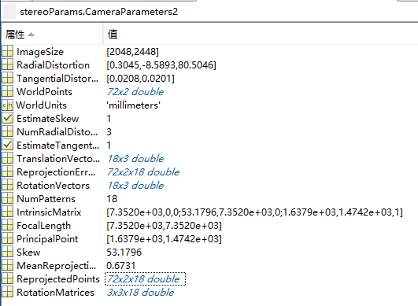

**2.2.1 stereoParams.CameraParameters2.IntrinsicMatrix**

7351.97823087610 0 0

53.1795796695527 7352.02889760308 0

1637.89205830372 1474.16645815975 1

**2.2.2 stereoParams.CameraParameters2.RotationMatrices**

val(:,:,1) =

0.9766 -0.0085 0.2149

0.0169 0.9992 -0.0372

-0.2144 0.0400 0.9759

val(:,:,2) =

-0.6197 -0.6743 0.4015

0.7078 -0.7012 -0.0852

0.3390 0.2314 0.9119

val(:,:,3) =

-0.9921 0.0055 -0.1251

-0.0325 -0.9762 0.2145

-0.1209 0.2169 0.9687

val(:,:,4) =

0.7925 0.6038 -0.0861

-0.5996 0.7454 -0.2913

-0.1117 0.2825 0.9527

val(:,:,5) =

0.9931 0.0001 0.1173

0.0311 0.9640 -0.2640

-0.1131 0.2659 0.9574

val(:,:,6) =

0.8780 0.4423 -0.1833

-0.4415 0.5999 -0.6672

-0.1851 0.6667 0.7219

val(:,:,7) =

0.5263 -0.0327 0.8497

0.1792 0.9811 -0.0733

-0.8312 0.1909 0.5222

val(:,:,8) =

0.6586 -0.0209 0.7522

0.1512 0.9829 -0.1051

-0.7372 0.1830 0.6505

val(:,:,9) =

0.8665 -0.0190 0.4988

0.1115 0.9814 -0.1562

-0.4866 0.1909 0.8525

val(:,:,10) =

0.6075 -0.7094 0.3572

0.7868 0.5993 -0.1479

-0.1092 0.3709 0.9222

val(:,:,11) =

0.7167 -0.6950 0.0571

0.6937 0.7022 -0.1601

0.0712 0.1543 0.9854

val(:,:,12) =

0.0733 -0.9965 0.0414

0.9182 0.0512 -0.3927

0.3892 0.0668 0.9187

val(:,:,13) =

-0.6625 -0.7209 0.2037

0.7323 -0.6805 -0.0265

0.1577 0.1316 0.9787

val(:,:,14) =

0.2189 -0.7964 0.5638

0.9503 0.0429 -0.3084

0.2214 0.6033 0.7662

val(:,:,15) =

0.1835 -0.8618 0.4728

0.9497 0.0312 -0.3117

0.2539 0.5062 0.8242

val(:,:,16) =

-0.0769 -0.9836 0.1632

0.9531 -0.0245 0.3017

-0.2927 0.1787 0.9393

val(:,:,17) =

-0.7588 -0.6329 0.1537

0.6513 -0.7382 0.1758

0.0023 0.2335 0.9724

val(:,:,18) =

0.1145 -0.9731 0.1999

0.9374 0.0392 -0.3461

0.3290 0.2271 0.9166

**2.2.3 stereoParams.CameraParameters2.TranslationVectors**

-1402.61710414216 -1056.82256484115 7437.48650525380

-611.560838396337 -586.126981599101 9248.61379796737

-378.139399416067 -367.221585543591 7262.23432243093

-928.353016828641 -985.768258643031 7501.61625521279

-850.437285359156 -599.039948957170 6522.93673626125

-798.103427949340 -647.591939617259 6606.13531797107

-1173.58699849726 -578.796507742386 5914.00320333777

-878.541508816932 -578.863807932265 5861.57794073513

-755.651857938278 -582.632421206794 6104.48487002434

-1200.96144313198 -368.373703663483 6235.07557818274

-1201.64554335214 -879.990191275129 7929.68487780423

-701.666644914254 -377.543554980478 7977.08447180418

-1006.61795419764 -518.834553718857 8361.82338268312

-1309.81168040732 -389.662434780929 8037.36673059100

-835.297450512462 -446.960049779437 8606.67973395066

-660.091730593617 -467.981245776656 8687.85582718966

-367.674645661386 -554.818233248545 8795.40455930433

-995.036663381924 -520.884889847860 9372.27343944286

**2.2.4 stereoParams.CameraParameters2.RotationVectors**

-0.0389010722375374 -0.216415188095037 -0.0127642580289882

-0.524755771594845 -0.103601350016349 -2.29097593114107

-0.193602300766436 0.339477552530901 3.09789421169819

-0.314059162312071 -0.0139771905078609 0.658650450261039

-0.268787647873028 -0.116846782668277 -0.0156895831251771

-0.773166442565106 -0.00103597421070404 0.512222067368651

-0.158662556863566 -1.00979476923009 -0.127316597053719

-0.163871514325028 -0.847261681270802 -0.0978754114967737

-0.182759558037204 -0.518877133764377 -0.0687159580770980

-0.305108025370425 -0.274320614474963 -0.879972866217828

-0.174958387380461 0.00783146625148360 -0.772693534034678

-0.355991162109138 0.269465539917132 -1.48344250538955

-0.250969517055094 -0.0729646447256268 -2.30670522361604

-0.709733978179824 -0.266513425567431 -1.35971679137137

-0.634613307793679 -0.169842669364715 -1.40541289660185

0.101909704078900 -0.377795839913679 -1.60493597920073

-0.108728521972488 -0.285281699308601 -2.41854788205256

-0.440359266328048 0.0991247348532343 -1.46776752708620